UNITED STATES
SECURITIES AND EXCHANGE COMMISSION
Washington, D.C. 20549

FORM 6-K

REPORT OF FOREIGN PRIVATE ISSUER

Pursuant to Rule 13a-16 or 15d-16 Under the
Securities Exchange Act of 1934

For the month of October 2026

Commission File Number: 001-42931

Grupo Aeroméxico, S.A.B. de C.V.
(Name of registrant)

Aeromexico Group
(Translation of registrant’s name into English)

Avenida Paseo de la Reforma 243, 25th Floor
Col. Cuauhtémoc, Cuauhtémoc 06500
Mexico City
United Mexican States
+52 (55) 9132 4000
(Address of principal executive office)

Indicate by check mark whether the registrant files or will file annual reports under cover Form 20-F or Form 40-F.

Form 20-F ☒ Form 40-F ☐

EXPLANATORY NOTE

On October 19, 2026, Grupo Aeroméxico, S.A.B. de C.V. (the “Company”) issued a press release titled “U.S. DOT Revocation of Schedule Restrictions Affecting Mexico-U.S. Service.”. A copy of this press release is furnished with this Form 6-K as Exhibit 99.1.

EXHIBIT INDEX
Exhibit |  |  |  |  |  | Description
99.1 |  |  | Press Release dated October 19, 2026, titled “U.S. DOT Revocation of Schedule Restrictions Affecting Mexico-U.S. Service.”

SIGNATURE

Pursuant to the requirements of the Securities Exchange Act of 1934, the registrant has duly caused this report to be signed on its behalf by the undersigned, thereunto duly authorized.
 |  |  | Grupo Aeroméxico, S.A.B. de C.V.
Date: October 19, 2026 |  |  | By: |  |  | /s/ Ernesto Gómez Pombo
 |  |  | Name: |  |  | Ernesto Gómez Pombo
 |  |  | Title: |  |  | General Counsel

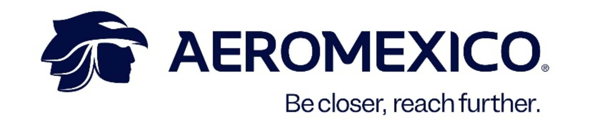
U.S. DOT Revocation of Restrictions Affecting Mexico-U.S. Service

Mexico City, October 19, 2026 – Grupo Aeroméxico, S.A.B. de C.V. (“Aeromexico” or the “Company”) (BMV & NYSE: AERO) announced today that the U.S. Department of Transportation (“DOT”) has revoked, effective immediately, its October 28, 2025 order that had disapproved certain existing, proposed and prospective schedules by Mexican air carriers between Mexico and the United States.

As a result of the DOT’s action, the restrictions imposed under that order no longer prevent Aeromexico from adding frequencies or introducing new scheduled services between Mexico City International Airport (“MEX”) or Felipe Ángeles International Airport (“AIFA”) and the United States, subject to applicable regulatory requirements.

Aeromexico welcomes the DOT’s decision and commends the Governments of Mexico and the United States for their continued engagement and efforts to strengthen the bilateral aviation relationship. Aeromexico expresses its deep appreciation to the Ministries of Foreign Affairs (“SRE”) and Infrastructure, Communications and Transportation (“SICT”) for their leadership, efforts and constructive engagement throughout this process. The DOT determined that the actions taken by the Government of Mexico addressed the concerns underlying its prior order.

The revocation gives Aeromexico greater flexibility to evaluate opportunities to expand frequencies and introduce new services between Mexico City and the United States, further strengthening connectivity for its customers across its transborder network.

Contact:
Investor Relations aminvestorrelations@aeromexico.com
Corporate Communications amcomunicacioncorporativa@aeromexico.com

About Grupo Aeroméxico
Grupo Aeroméxico, S.A.B. de C.V. is a holding company whose subsidiaries are engaged in commercial aviation in Mexico and the promotion of passenger loyalty programs. Aeroméxico, Mexico’s global airline, has its main hub at Terminal 2 of Mexico City International Airport. Its destination network covers Mexico, the United States, Canada, Central America, South America, Asia and Europe. The Group’s current operating fleet includes Boeing 787 and 737 aircraft, as well as Embraer 190 aircraft. Aeroméxico is a founding member of SkyTeam, an alliance that has been operating for more than 25 years and offers connectivity in more than 145 countries through its 18 member airlines.

www.aeromexico.com
www.skyteam.com

Forward-Looking Statements
This press release contains certain forward-looking statements within the meaning of the Private Securities Litigation Reform Act, which reflect the current views and/or expectations of the Company and its management regarding its performance, business and future events. We use words such as “believes,” “anticipates,” “plans,” “expects,” “intends,” “target,” “estimates,” “projects,” “foresees,” “guidance,” “forecast,” “outlook” and other similar expressions to identify such statements. These statements are subject to various risks, uncertainties and assumptions. Several factors could cause actual results to differ materially from the plans, objectives, expectations, estimates and intentions expressed in this press release. Such factors include, among others: external risks, safety and security concerns, health threats, accidents, global instability, security breaches, terrorism and natural disasters; economic and geopolitical conditions in Mexico and internationally, as well as their impact on customer travel behavior and fuel prices; volatility in the fuel market; the Company’s ability to meet its financial obligations, obtain financing and maintain liquidity; its ability to attract and retain key personnel, as well as the Company’s labor relations with its employees; dependence on aircraft manufacturers and other suppliers; aircraft maintenance costs and utilization; changes in airport fees; air traffic congestion; the competitive environment of the aviation industry; dependence on partnerships and alliances, as well as the challenges of entering into new partnerships and alliances; and other factors described in the “Risk Factors” section of the Company’s annual report on Form 20-F filed with the SEC on April 30, 2026, as well as in other documents filed with or furnished to the SEC. Forward-looking statements are based on information available at the time they are made and on management’s good-faith belief regarding future events. The Company undertakes no obligation to update or revise any forward-looking statements, except as required by applicable law. The Company also undertakes no obligation to inform the market, through official announcements, of future purchases of shares by its directors and officers, except as required by applicable law.

